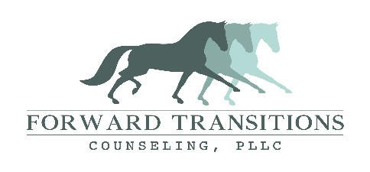

Dear Forward Transitions Clients,
There is no higher priority than the health and safety of our Forward Transitions Counseling families, community, and therapists. We want to assure you that as news about the coronavirus (COVID-19) pandemic continues to evolve, we are monitoring it closely and taking steps to promote wellness and safety. We are following guidance from the Centers for Disease Control and Prevention (CDC), the World Health Organization (WHO), and local/federal government and public agencies to inform our decisions. As a community partner, we believe it is of the utmost importance to take precautionary measures at this time.
We are currently working on being able to offer Telemental health. We anticipate this to be up and running, for at least the short term, by the end of this week. We are prepared to continue to see clients this week, but ask that you reschedule if you have a cough, shortness of breath, and/or a fever. We are happy to set up a phone or telehealth session if you are ill or if you prefer to stay home. We have taken a few extra precautions in sanitizing things around the office and office building.
We are prepared to navigate through these challenging circumstances with you and will keep you informed of any additional steps that we take in the weeks to come. Our hearts go out to all who have been affected by the outbreak of COVID-19. The CDC recommends the following guidelines to keep you healthy and prevent the spread of the coronavirus: • Wash your hands often with soap and water for at least 20 seconds • Use an alcohol-based sanitizer • Keep away from others that are sick • Avoid touching high-touch surfaces in public places • Avoid touching your face, nose, eyes, etc. • Clean and disinfect household objects and surfaces in your home • Avoid all non-essential travel According to the CDC, if you think you have been exposed to COVID-19 and develop a fever and symptoms of respiratory illness, such as cough or difficulty breathing, call your healthcare provider immediately. Your healthcare professional will work with your state’s public health department and the CDC to determine if you need to be tested for COVID-19. If you are feeling unwell, we ask that you please take steps to safeguard others and remain at home. Please refer to the CDC website for more information and updates and continue to check-in via email or by phone for updates from Forward Transitions Counseling.

With Gratitude,
Cari Denham, MA, LMFT
Founder/Therapist Forward Transitions Counseling, PLLC
682-352-0000
caridenhamlmft@gmail.com

